**React JS**

**Introduction**

* The React.js is an open-source JavaScript framework and library developed by Facebook. It’s used for building interactive user interfaces and web applications quickly and efficiently.
* Primary role of React in an application is to handle the view layer of that application just like the V in a model-view-controller (MVC) pattern by providing the best and most efficient rendering execution.
* Before starting we should have a basic understanding of HTML, CSS, DOM, ES6, Node.js and npm.
* Because of its ability to create fast, efficient, and scalable web applications, React has gained stability and popularity. Thousands of web applications use it today, from well-established companies to new start-ups. Some of the popular examples are as under:

**Facebook, Instagram, Netflix, Reddit, Uber, Airbnb, The New York Times, Khan Academy, Codecademy, WhatsApp Web**

**History**

* React was created by Jordan Walke, a software engineer at Meta, who initially developed a prototype called "F-Bolt", later renaming it to "FaxJS".
* This early version is documented in Jordan Walke's GitHub repository. Influences for the project included XHP, an HTML component library for PHP.
* React was first deployed on Facebook's News Feed in 2011 and subsequently integrated into Instagram in 2012.
* In May 2013, at JSConf US, the project was officially open-sourced.

**About React**

* **Component based approach:** A component is one of the core building blocks of React. In other words, we can say that every application you will develop in react will be made up of pieces called components. Components make the task of building UIs much easier.
* **Uses a declarative approach:** Declarative programming is a programming paradigm that expresses the logic of a computation without describing its control flow.
* DOM (Document Object Model) updates are handled gracefully.
* Reusable code.

**Setup of React JS**

* **Step 1**: Install Node.js installer for windows.
* **Step 2**: Open command prompt  or terminal in VS code to check whether it is completely installed or not.

**node -v**

If the installation went well it will give you the version you have installed

* **Step 3:** Now Create a new folder where you want to make your react app using the below command:

**mkdir react**

***Note:****The****react****in the above command is the name of the folder and can be anything.*

Move inside the same folder using the below command:

**cd react**

* **Step 4:** Now, go inside **folder(react)**.
* The **npm** stands for **Node Package Manager**and itis the default package manager for [**Node.js.**](https://www.geeksforgeeks.org/introduction-to-nodejs/)  It gets installed into the system with the [**installation of node.js.**](https://www.geeksforgeeks.org/installation-of-node-js-on-windows/)
* The **npx** stands for **Node Package Execute** and it comes with the npm, when you installed npm above 5.2.0 version then automatically npx will be installed. It is an npm package runner that can execute any package that you want from the npm registry without even installing that package. Using the NPX package runner to execute a package can also help reduce the pollution of installing lots of packages on your machine.

**In npx you can create a react app without installing the package:**

**`npx create-react-app myApp`**This command is required in every app’s life cycle only once.

***Run below command if not able to create a react app using above command.***

***`npm install -g create-react-app`***

**By creating a react app folder structure will be looked as shown in next topic called “Folder Structure” image.**

* **Step 5:** Now, go to **myApp**(Created react app) folder

**cd myApp**

* **Step 6:** To start your app run the below command:

**npm start**

Once you run the above command, a new tab will open in your browser showing React logo as shown below:

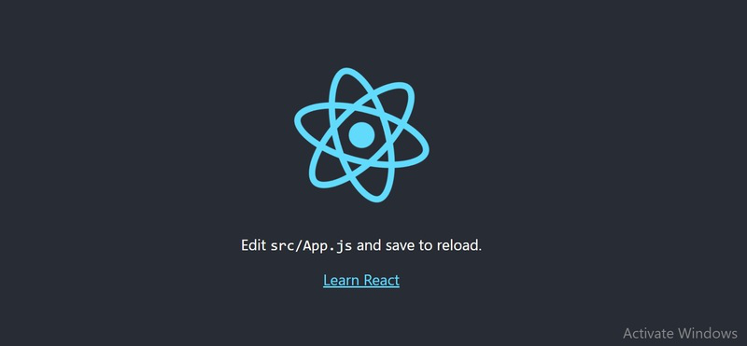

**Folder Structure**

**Once a react app gets created, The folder structure looks as below.**

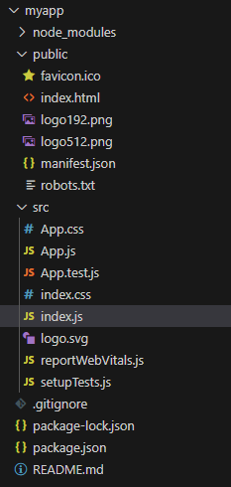

**node_modules**

* In this folder, you will get various folders of all the required dependencies & packages that may be used for building your react app. For example – Webpack, Babel, JSX, Jest & more.
* You not need to modify the node_module.
* It is already configured with the react app.

**Public**

* The public folder contains static files such as index.html, javascript library files, images, and other assets, etc. which you don’t want to be processed by **webpack**.
* Files in this folder are copied and pasted as they are directly into the build folder. Only files inside the `public` folder can be referenced from the HTML.

Webpack in react is a JavaScript module bundler that is commonly used with React to bundle and manage dependencies. It takes all of the individual JavaScript files and other assets in a project, such as images and CSS, and combines them into a single bundle that can be loaded by the browser.

* If you put assets in the public folder and you have to give their reference in your project, then you will have to use a special variable that is called **PUBLIC_URL**.
* A file that remains in the public folder, will be accessible by **%PUBLIC_URL%**.

**For example –**

**<link rel=”icon” href=”%PUBLIC_URL%/favicon.ico” />**

* When you run the npm build command to deploy your project, create-react-app will convert %PUBLIC_URL% to the right absolute path of your application. So that it can work well if you use host/client-side routing at a non-root URL

#### favicon.ico

* This the default react icon that always remains in the public folder. you can also put here your own project icon but the icon extension must be .ico and the icon name may be anything.
* You can remove favicon.ico when you place a new favicon for your project/website.
* When you open your app in the web browser, you will see an icon in the tab on the left side. It is the symbol of your application. So, you should not leave it.

#### **index.html**

* This is the index file that displays when the react app opens in the web browser. It contains the HTML template of the react application.
* index.html file is the root file of the react app. Everything will be rendered through it on the front end. So, Don’t try to change & remove this file from the public folder.

**Note – index.html must exist in the public folder and you must not delete it otherwise you will get an error.**

#### **logo192.png & logo512.png**

* These are the logos of react js. It is placed just for the initial view of react app. you can remove/leave it depends on you.

#### **manifest.json**

* manifest.json provides the metadata like short_name, name & icons in the form of JSON for a react application. It may be installed on the mobile or desktop. So that you can directly open the react application with its installed favicon.
* Due to the manifest.json file, users get a notification to install react application on their mobile or desktop.
* You must not remove manifest.json but you can modify JSON values according to your project

#### **robots.txt**

* **The robot.txt file is given just for SEO purposes.** As a developer, you need not do anything with this file. This file is not related to development.

### **src**

* **In the src folder, You can put all the js, CSS, images, components file & other assets of your projects.**
* By default, we get the following files that are necessary to understand their usages. you can create your own files according to these files for developing your projects.

#### **App.css**

* **App.css file contains a default CSS code and import into the App.js file.** It is also global, you can import another file. You can create your own CSS file like App.css but make sure that its name must start with the uppercase letter and.
* for example – **Myapp.css**

#### **App.js**

* **App.js is a parent component file of your react app. It is imported into the index.js file to render content/HTML in the root element that remains in public/HTML.**
* You can also create your own component file according to App.js but make sure that its extension must be .js and its name must start with an uppercase letter (recommended).
* for an example – Myapp.js.

#### **App.test.js**

* **App.test.js  gives us a testing environment**. Basically, it’s written code to protect the react application to be crashed.
* We also need not modify & remove this file from the react application.

#### **index.css**

* **index.css file contains some default css code for index.js**. You can modify/add some new CSS code according to your project design pattern.

#### **index.js**

* **index.js file is an entry point of react app**. Means that all the component renders through this file to the index.html.
* Basically, your application executes properly with the help of index.js. Even all the js files of components are imported in this file.
* for example – **As App.js file is imported  with  using import App from './App'** .
* If you want to add your own module then you also have to import your own Myapp.js file using the  import Myapp from './Myapp' in index.js file;

#### **logo.svg**

* This is the default logo of react js. You can remove it and place your project logo.

#### **reportWebVital.js**

* reportWebVital.js is related to the speed of your application.  You also need not to do anything with this file.

#### **setupTest.js**

* In this file, @testing-library/jest-dom is imported. You need not modify and remove it from the application

### **.gitignore**

* .**gitignore file is used to ignore those files that have not to be pushed to the git.**
* By default, dependencies, testing folders/files are defined in the .gitignore. When you push your app to the git, these folders/files will not be pushed.

### **package-lock.json**

* **package-lock.json file maintains a version of installed dependencies.**

### **package.json**

* **All the dependencies are defined in this file.**  It maintains which dependencies are necessary for our application

### **README.md**

* **In this file, Some instructions are written to configure and set up the react application.**
* Even you can also write more instructions for your project that will help the developer to configure it easily.

***Index.html > index.js > App.js file will be called.***

**Index.html**

<!DOCTYPE html>

<html lang="en">

  <head>

    <meta charset="utf-8" />

    <link rel="icon" href="%PUBLIC_URL%/favicon.ico" />

    <meta name="viewport" content="width=device-width, initial-scale=1" />

    <meta name="theme-color" content="#000000" />

    <meta

      name="description"

      content="Web site created using create-react-app"

    />

    <link rel="apple-touch-icon" href="%PUBLIC_URL%/logo192.png" />

**<!-- Notice the use of %PUBLIC_URL% in the tags above. It will be replaced with the URL of the `public` folder during the build. Only files inside the `public` folder can be referenced from the HTML. Unlike "/favicon.ico" or "favicon.ico", "%PUBLIC_URL%/favicon.ico" will work correctly both with client-side routing and a non-root public URL  -->**

**<!-- manifest.json provides metadata used when your web app is installed on a user's mobile device or desktop. -->**

    <link rel="manifest" href="%PUBLIC_URL%/manifest.json" />

<title>React App</title>

  </head>

<body>

    <noscript>You need to enable JavaScript to run this app.</noscript>

**<div id="root"></div>**

**<!-- This HTML file is a template. If you open it directly in the browser, you will see an empty page. You can add webfonts, meta tags, or analytics to this file. The build step will place the bundled scripts into the <body> tag.  -->**

  </body>

</html>

**Index.js**

import React from 'react';

import ReactDOM from 'react-dom/client';

import './index.css';

**import App from './App';**

import reportWebVitals from './reportWebVitals';

const root = ReactDOM.createRoot(**document.getElementById('root')**);

root.render(

  <React.StrictMode>

**<App />**

  </React.StrictMode>

);

**// If you want to start measuring performance in your app, pass a function to log results (for example: reportWebVitals(console.log)) or send to an analytics endpoint.**

reportWebVitals();

**React.StrictMode is a tool that highlights potential issues in a programme. It works by encapsulating a portion of your full application as a component. StrictMode does not render any visible elements in the DOM in development mode, but it enables checks and gives warnings.**

**React render**

React renders HTML to the web page by using a function called **createRoot()** and its method **render()**.

**The createRoot Function**

The createRoot() function takes one argument, an HTML element.

The purpose of the function is to define the HTML element where a React component should be displayed.

**The render Method**

The render() method is then called to define the React component that should be rendered.

When building web applications in React, you use two packages—**react and react-dom.**

The react package holds the react source for components, state, props and all the code that is react.

The **react-dom** package as the name implies is the glue between React and the DOM. Often, you will only use it for one single thing: mounting your application to the index.html file with **ReactDOM.render()**.

Why separate them?

The reason React and ReactDOM were split into two libraries was due to the arrival of **React Native** (A react platform for mobile development).

React components are such a great way to organize UI that it has now spread to mobile to react is used in web and in mobile. react-dom is used only in web apps.

**Note:** Previously we had to **import React** because the JSX is converted into regular Javascript that use react's React.createElement method.

But, React has introduced a new JSX transform with the release of React 17 which automatically transforms JSX without using React.createElement. This allows us to not import React, however, **you'll need to import React to use Hooks and other exports that React provides. But if you have a simple component, you no longer need to import React**. All the JSX conversion is handled by React without you having to import or add anything.

They work together like a **brain (react)** and a **hand (react-dom)**—react decides what to show, and react-dom makes it appear on screen.

* **react**
  + Understands JSX (<h1>, <button>, etc.)
  + Manages component logic (useState, rendering, updating)
* **react-dom**
  + Finds document.getElementById('root')
  + Injects React's virtual DOM into the actual browser DOM
  + Updates the DOM when state/props change

**App.js**

import logo from './logo.svg';

import './App.css';

**function App() {**

**return (**

**<div className="App">**

      <header className="App-header">

        <img src={logo} className="App-logo" alt="logo" />

        <p>

          Edit <code>src/App.js</code> and save to reload.

        </p>

        <a

          className="App-link"

          href="https://reactjs.org"

          target="_blank"

          rel="noopener noreferrer"

        >

          Learn React

        </a>

      </header>

**</div>**

**);**

**}**

**export default App;**

**JSX (JavaScript XML)**

* JSX is a syntax extension for JavaScript that lets you write HTML-like markup inside a JavaScript file.
* Each React component is a JavaScript function that may contain some markup that React renders into the browser.
* React components use a syntax extension called JSX to represent that markup.
* JSX looks a lot like HTML, but it is a bit stricter and can display dynamic information.

**Simple HTML code**

<h1>LJU students</h1>

<ul>

<li>CSE</li>

<li>IT</li>

<li>CE</li>

</ul>

**And if we want to put HTML code into our component:**

function Ex1() {

return (

**// If you copy and paste above code as it is here, it will not work and give an error: “Adjacent JSX elements must be wrapped in an enclosing tag. Did you want a JSX fragment <>...</>? “**

)

}

export default Ex1

**As we must have to follow the rules of JSX**

**The Rules of JSX**

1. **Return a single root element**

To return multiple elements from a component, wrap them with a single parent tag.

For example, you can use a <div>:

<div>

<h1>LJU students</h1>

<ul>

<li>CSE</li>

<li>IT</li>

<li>CE</li>

</ul>

</div>

If you don’t want to add an extra <div> to your markup, you can write **<> and </>** instead if “<div>” tag

This empty tag is called a **Fragment**. Fragments let you group things without leaving any trace in the browser HTML tree.

1. **Close all the tags**

JSX requires tags to be explicitly closed: self-closing tags like <img> must become <img />, and wrapping tags like “<li>oranges” must be written as <li>oranges</li>.

1. **camelCase are required**

* JSX turns into JavaScript and attributes written in JSX become keys of JavaScript objects.
* In your own components, you will often want to read those attributes into variables.
* But JavaScript has limitations on variable names. For example, their names can’t contain dashes or be reserved words like **class**.
* This is why, in React, many HTML and SVG attributes are written in camelCase. For example, instead of **stroke-width** you use **strokeWidth**.
* Since **class** is a reserved word, in React you write **className** instead.

<img src=" " alt=" " **className**="photo" />

1. **Passing expression**

If you want to dynamically specify the src or alt text in img tag. You could use a value from JavaScript by replacing " and " with { and }

Import **pic** from “./img.jpg”

function Avatar() {

**const description = 'test image';**

return (

<img className="pic" src=**{pic}** alt=**{description}** />

);

}

export default Avatar;

Note: The **className="pic"**, which specifies an **"pic" CSS class name** that applies css to the image

**src={pic}** that reads the value of **pic which is imported**. That’s because **curly braces** let you work with JavaScript right there in your markup!

**You can only use curly braces in two ways inside JSX:**

As text directly inside a JSX tag: **<h1>{name}'s To Do List</h1>** works, but <{tag}> Test’s To Do List</{tag}> will not work.

As attributes immediately following the **= sign: src={pic}** will read the avatar variable, but src="{pic}" will pass the string "{pic}".

1. **Using “double curlies”: CSS and other objects in JSX**

* In addition to strings, numbers, and other JavaScript expressions, you can even pass objects in JSX.
* You may see this with inline CSS styles in JSX.
* React does not require you to use inline styles (CSS classes work great for most cases). But when you need an inline style, you pass an object to the style attribute:

function Subtraction() {

    return(

        <div>

            <h1 style**={{backgroundColor:'red',color:'#fff'}}**>Subtraction : {7-4}</h1>

         </div>

    )

};

**OR**

function Subtraction() {

var **mystyle** = **{backgroundColor:'red',color:'#fff'};**

    return(

        <div>

            <h1 style**={mystyle}**>Subtraction : {7-4}</h1>

         </div>

    )

};

**JSX Comments**

To write comments in React (JSX), we need to wrap **them in curly braces**.

Function comment() {

Return(

**{/* this works */ }**

)

}

The curly braces tell the JSX parser to parse the code inside as JavaScript, and not a string.

Since the contents inside are parsed as JavaScript, this enables us to also do multi-line or single-line comments:

function comment(){

return (

**<>**

{

**/\***

**mult-line**

**test**

**\*/**

}

{

**// single-line test**

}

**</>**

)}

In the case of a single-line comment, You cannot have the ending bracket in the same line, because that will break everything.

**React Components**

* **A react component is a JavaScript function that you can sprinkle with markup**
* **React lets you create components, reusable UI elements for your app.**
* **In a React app, every piece of UI is a component.**
* **React components are regular JavaScript functions except:**
  + **Their names always begin with a capital letter.**
  + **They return JSX markup.**

**Example1**

**Build basic react app that display “Hello World” in browser.**

1. **Make changes in existing component App.js as shown below.**

**App.js**

function App() {

  return (

**<div>**

**<h1>Hello World!</h1>**

**</div>**

  );

}

export default App;

**This App.js file is imported as a component in index.js file as we have shown above.**

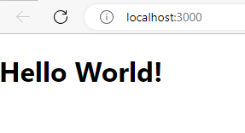

**This App.js file can also be considered as a component. As we are exporting it and importing in the file index.js. We can reuse this component just by importing it.**

**App.js is the default component file. If you don’t want to make changes in this component file then create your own component file i.e. Myapp.js and make changes in it. And call your component file in index.js.**

**Myapp.js**

function Myapp() {

  return (

**<div>**

**<h1>Hello World!</h1>**

**</div>**

  );

}

export default Myapp;

**This Myapp.js file is imported as a component in index.js file.**

1. **Create file named ex1.js as a component and import this component in App.js or Myapp.js file.**

**Myapp.js**

**import Ex1 from "./Ex1";**

function Myapp() {

return (

<div>

**<Ex1/>**

</div>

);

}

export default Myapp;

**Ex1.js**

function **Ex1**() {

    return(

         <div>

              <h1>Hello World!</h1>

         </div>

    )

}

export default **Ex1**;

**This App.js or Myapp.js file is imported as a component in index.js file as we have shown above.**

**Note: Please try to follow lastmethod of importing component to App.js or Myapp.js file. In this file just import component and call this component as shown in above example.**

**Create component using arrow function**

**Ex1.js**

**const Ex1=()=> {**

    return(

         <div>

              <h1>Hello World!</h1>

         </div>

    )

}

export default **Ex1**;

**Example**

**Write React code to render a component with the following data:**

* **A heading in italics, blue color, and font-size 25px.**
* **An image.**
* **An ordered list of 3 fruits that start with the letter "A".**
* **The current time and current date in red color, centered.**

**App1.js**

import **img1** from "./image.jpg"

function App1() {

const **date**=new Date().toLocaleDateString()

const **time**=new Date().toLocaleTimeString()

return (

    <div>

      <h1 style = {{color:"blue", fontStyle: "italic", fontSize: "25px"}}>Hello, Good Morning!</h1>

      <h3> List of fruits</h3>

          <ol type="A">

             <li>Apple</li>

            <li>Lichi</li>

            <li>Kiwi</li>

          </ol>

          <img src={**img1**} alt="image"/>

          <h6>Current Date: {**date**}</h6>

          <h6>Current Time: {**time**}</h6>

    </div>

) }

export default App1;

**Note**: Styling info must be written inside two sets of curly braces {{}}. If dashed property name is used like background-color, font-size, then we have to use camel case names of properties like backgroundColor, fontSize.

**\*\*new Date().toLocaleDateString()**: The toLocaleDateString() method returns the date (not the time) of a date object as a string, using locale conventions.

**\*\*new Date().toLocaleTimeString()**: The toLocaleTimeString() method returns the time portion of a date object as a string, using locale conventions.

**Map and Filter**

**Map**

* In React, the Map method used to traverse and display a list of similar objects of a component.
* Often, we find ourselves needing to take an array and modify every element in it. Use .map() whenever you need to update data inside an array (by mapping over it!).
* A map is not the feature of React. Instead, it is the standard JavaScript function that could be called on any array.
* The map() method creates a new array by calling a provided function on every element in the calling array.

**Example-1**

**Write React code to render a component to display all array elements in h2 tag using map function.**

**Map1.js**

import React from 'react';

function **Map1**() {

const **arr**=[1,2,3,4,5];

return (

<div>

<h1>Example of mapping</h1>

**{**

**arr**.**map**((value)=>

{

return <h2>Array Element= {value}</h2>

})

**}**

</div>

)

}

export default **Map1**

**Myapp.js**

import **Map1** from "./Map1";

function **Myapp**() {

return (

<div>

<**Map1**/>

</div>

);

}

export default **Myapp**;

**This Myapp.js file is imported as a component in index.js file**

**Output:**

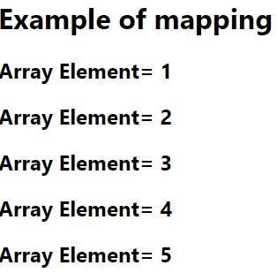

**Example-2**

**Write React code to render a component having an array of strings and convert it in Uppercase using map method.**

**Arraymap.js**

const **Arraymap** = () => {

const **arr**=["a","b","c","d","e"];

return (

<div>

<h1>map function</h1>

{ **arr**.**map**((value)=> {

return <p>array values= {value.**toUpperCase()**}</p>

})

}

</div>

) }

export default **Arraymap**

**Output:**

**map function**

array values= A

array values= B

array values= C

array values= D

array values= E

**Example-3**

**We have an array of numbers and we want to multiply each of these numbers by 5. Write React code to render a component to display these multiplied numbers using map function.**

**Map2.js**

function Map2() {

let arr = [2, 4, 6, 3, 10, 12]

return (

<div>

<h1>Multiplication of numbers are as under: </h1>

{

arr.**map**((value)=>

{

return <h2>**{value}** * 5 = **{value * 5}**</h2>

})

}

</div>

)

}

export default Map2

**Output:**

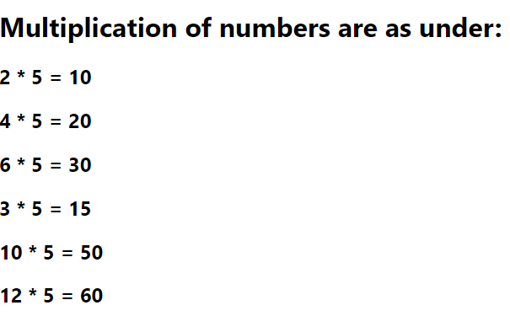

**Example-4**

**Write React code to render a component which displays images using map function.**

**Map3.js**

import React from 'react';

import img1 from "./img1.png" //import image from same folder

import img2 from "./img2.png" //import image from same folder

function Map3() {

const **images**=[{id:2,**pic**:img1},{id:2,pic:img2}];

return (

<div>

**{images.map((val) => {**

**return <img src={val.pic} heigth="200px" width="200px" alt="logo" />**

**})}**

</div>

)

}

export default Map3

**Output: This will display two images.**

**Example: map with condition**

**Write React code to render a component which displays array elements which are greater than 3.**

**Map4.js**

function Map4() {

const **arr**=[1,2,3,4,5,3,6,4,3,1];

return (

<div>

<h1>Example of mapping with condition</h1>

{

**arr**.**map**((**value**)=>

{ **if(value>3){** return (<h2 >Array Elements= {**value**}</h2>)**}** }

)}

</div>

)}

export default Map4

**The result of the map() call is:**

[

undefined,

undefined,

undefined,

<h2>4</h2>,

<h2>5</h2>,

undefined,

<h2>6</h2>,

<h2>4</h2>,

undefined,

undefined

]

**React takes that array and renders only the valid JSX elements. It skips all the undefineds, so you only see:**

Array Elements = 4

Array Elements = 5

Array Elements = 6

Array Elements = 4

### **Best Practice:**

To avoid unnecessary **undefined** values (even if they’re harmless here), prefer:

**arr.filter(val => val > 3).map(val => <h2>{val}</h2>)**

It keeps your logic **cleaner**, **predictable**, and **debug-friendly**.

**List and Keys**

* Lists are very useful when it comes to developing the UI of any website.
* Lists are mainly used for displaying menus on a website, for example, the navbar menu. In regular JavaScript, we can use arrays for creating lists.
* A “key” is a special string attribute you need to include when creating lists of elements in React.
* If **lists** do not include the **key** attribute, then it will give below warning. The warning says that each of the list items in our unordered list should have a unique key.

**Warning: Each child in an array or iterator**

**should have a unique "key" prop**

Keys are used in React to identify which items in the list are changed, updated, or deleted. In other words, we can say that keys are used to give an identity to the elements in the lists. It is recommended to use a string as a key that uniquely identifies the items in the list.

**List.js**

function List() {

const students = [

{id: 1, name: 'ABC'},

{id: 2, name: 'XYZ'},

{id: 3, name: 'PQR'}

];

return(

<ul>

{

students.map((student) =>

{

return <li **key={student.id}**>{student.name}</li>

})

}

</ul>

)

}

export default List

**OR**

**List.js**

function List() {

const students = [

{id: 1, name: 'ABC'},

{id: 2, name: 'XYZ'},

{id: 3, name: 'PQR'}

];

return(

<ul>

{

students.map((student,**index**) =>

{

return <li **key={index}**>{student.name}</li>

})

}

</ul>

)

}

export default List

**Filter**

* filter() loops through data, and filters out data that doesn't match the criteria that we set.
* So, It's the process of looping through an array and including or excluding elements inside that array based on a condition that you provide.
* It is also built in JavaScript function.

**Write React component to skip digit “3” from an array and display all remaining digits of the array.**

**Filt1.js**

function Filt1() {

const arr = [1, 2, 3, 4, 5, 3, 7, 3, 9];

const newarr = arr.filter(num => num !== 3);

return (

<di>

<h1>

Array elements before applying filter:

<span style={{ color: "red" }}> {arr.join(", ")} </span>

</h1>

<h1>

Array elements after applying filter:

<span style={{ color: "red" }}> {newarr.join(", ")} </span>

</h1>

</div>

);

}

export default Filt1;

**Output:**

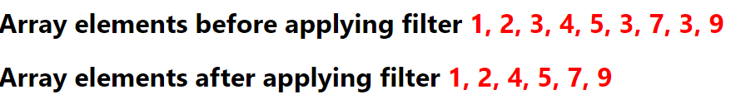

**To understand difference of output using map and filter refer below examples.**

**Example:**

**Write React code to filter out the numbers greater 6 using map/filter function.**

**Check difference in output using different methods.**

**Using Only map method**

const ArrayMap_condition = () => {

const arr1=[1,2,3,4,5,6,7,8,9]

return (

<div>

<h1>using map/filter function</h1>

{

**arr1.map((value)=>{**

**if(value <=6){**

**return <h1>array values= {value}</h1>**

**}**

**})**

}

</div>

)

}

export default ArrayMap_condition

**Output using map function:**

**using** **map/filter function**

array values= 1

array values= 2

array values= 3

array values= 4

array values= 5

array values= 6

**Cons:** The map method will still iterate over all elements, but only those that meet the condition will render something. **Others will effectively render undefined.**

**OR**

**Using Only filter method**

const ArrayMap_condition = () => {

const arr1=[1,2,3,4,5,6,7,8,9]

return (

<div>

<h1>using map/filter function</h1>

{

**arr1.filter((value)=>value <=6){**

**return <h1>array values= {value}</h1>**

**}**

**})**

}

</div>

)

}

export default ArrayMap_condition

**Output using filter function:**

**using map/filter function**

123456

**Filtering First**: arr1.filter filters the array to only include values less than or equal to 6 and displayed filtered values to without applying <h1> element.(returns only values)

**This is not valid because:**

* **filter() expects a boolean return value (true/false), not JSX.**
* **Returning a <h1> here doesn't make logical sense to .filter().**

### Optimized Approach: **filter first**, then map() to JSX.

**Using map and filter methods**

const ArrayMap_condition = () => {

const arr1=[1,2,3,4,5,6,7,8,9]

return (

<div>

<h1>using map/filter function</h1>

{

**arr1.filter((value)=>value <=6).map((value)=>{ return <h1>array values= {value}</h1>})**

}

</div>

)

}

export default ArrayMap_condition

**Output using map and filter function:**

**using** **map/filter function**

array values= 1

array values= 2

array values= 3

array values= 4

array values= 5

array values= 6

* **Filtering First**: arr1.filter((value) => value <= 6) filters the array to only include values less than or equal to 6.
* **Mapping with Keys**: **map((value)=>{ return <h1>array values= {value}</h1>})** maps the filtered values to <h1> elements.

**React Props**

* Props stand for "Properties." It is an object which stores the value of attributes of a tag and work similar to the HTML attributes.
* React components use props to communicate with each other. Each component can pass some information to other components by giving them props.
* Props are similar to function arguments. Props are passed to the component in the same way as arguments passed in a function.

**Let’s understand how to pass and read data using props by below example.**

**Step 1: Pass props to the component**

**Prop1.js**

import **Prop2** from "./ **Prop2**";

function **Prop1** () {

var **n** = “ABC”;

return (

<div>

<**Prop2 name**={**n**} **rollnum**="101" **marks**="20" />

<**Prop2 name**="DEF" **rollnum**="102" **marks**="16" />

<**Prop2 name**="GHI" **rollnum**="103" **marks**="22.5" />

</div>

);

}

export default **Prop1**;

**Step 2: Read props inside the component**

**Prop2.js**

function **Prop2**(props){

return(

<div>

<ul>

<li>{props.**name**}</li>

<li>{props.**rollnum**}</li>

<li>{props.**marks**}</li>

</ul>

</div>

);

}

export default **Prop2**;

**Output:**

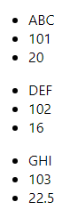

**Example:**

**Write a React code to print car’s brand name and its model name which are passed as props using JSON.**

**Ex2.js**

**import Ex3 from "./Ex3";**

function Ex2() {

const **carInfo** = { brand: "Kia", name: "Sonet" };

return (

<div>

<h1>Details of car</h1>

<**Ex3** **car**={ **carInfo** }/>

</div>

);

}

export default Ex2;

**Ex3.js**

import React from 'react';

function Ex3(**props**) {

return(

<>

<h2>Car Brand: { **props**.**car**.brand } </h2>

<h3>Car Name: { **props**.**car**.name }</h3>

</>

);

}

export default Ex3;

**Output:**

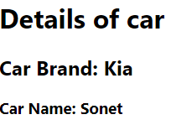

**Example**

**Write a program using ReactJS in which you’ve to create two variable names -Student_name and University_name, these both values should be passed to another component names_Details where these values are printed using props.**

**Example1.js**

import Example from "./Example";

function Example1 () {

const Details = {Student_name: "abc", University_name: "LJU"};

return (

<div>

<Example data ={ Details }/>

</div>

) }

export default Example1

**Example.js**

function Example(props) {

return(

<h2> My name is {props.data.Student_name}.

I am a student of { props.data.University_name } University !</h2>

) }

export default Example

**Output:**

My name is abc. I am a student of LJU University !

**Example**

**Build a React app that displays a list of products using props.**

* **Create a ProductCard component to show product details like title, price, rating, and image.**
* **Use a ProductList component to store product data and display multiple ProductCard components using .map().**

**ProductList.js**

import **ProductCard** from './ProductCard';

function ProductList() {

const **products** = [

{

title: "iPhone 15 Pro",

price: "$999",

rating: 4.8,

image: "https://example.com/iphone.jpg"

},

{

title: "Samsung Galaxy S24",

price: "$899",

rating: 4.5,

image: "https://example.com/galaxy.jpg"

},

{

title: "Google Pixel 8",

price: "$799",

rating: 4.6,

image: "https://example.com/pixel.jpg"

}

];

return (

<div>

<h1>Our Products</h1>

**<ProductCard productList={products} />**

</div>

);

}

export default ProductList;

**ProductCard.js**

function ProductCard(props) {

return (

<>

{

props.**productList**.map((product, index) => (

<div>

<img src={product.image} alt={product.title} width="100%" />

<h2>{product.title}</h2>

<p>Price: {product.price}</p>

<p>Rating: {product.rating}</p>

</div>

))

}

</>

);

}

**export default ProductCard;**

**React Events**

To handle events with React elements is very similar to handle events with DOM events. There are some syntax differences as below:

React events are named using camelCase, rather than lowercase as we used to do in HTML.

**In HTML:**

<button onclick="demofunction()">

LJ University

</button>

**In React:**

<button **onClick = { demoFunction }**>

LJ University

</button>

Another difference is that we cannot **return false** to prevent default behavior in React. We must call **preventDefault** explicitly.

**preventDefault** is used to prevent the default form behavior of submitting.

**In HTML**

<form onsubmit="console.log (' You clicked submit. '); return false">

<button type="submit">Submit</button>

</form>

**In React**

function Form () {

function **handleSubmit** (e) {

e.**preventDefault** ();

alert (' You clicked submit.');

}

return (

<form **onSubmit** = {**handleSubmit**}>

<button type="submit">Submit</button>

</form>

);

}

1. **Example of onclick event**

**Write react js script to display alert box with text “Welcome to LJU” by clicking on button.**

**Event1.js**

function Event1() {

const mystyle = {

color : "white",

backgroundColor: "#000000",

padding: "10px 20px",

margin: "200px"

};

function handleClick () {

alert ('Welcome to LJU');

}

return (

<div>

<center>

<button style = {mystyle} onClick={handleClick}>

Click me

</button>

</center>

</div>

);

}

export default Event1;

**App.js**

import Event1 from "./Event1"

function App() {

return (

<div>

<Event1/>

</div>

);

}

export default App;

**Output:**

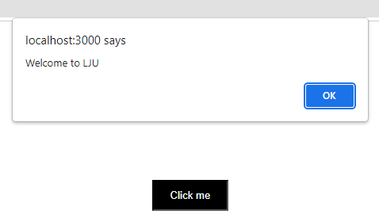

1. **Example of onchange event**

**Write react js script to display values in console while changing it in text box.**

**Event2.js**

import React from 'react';

function Event2() {

function handleChange(event) {

console.log (event.target.value);

}

return (

<input type=”text” name="firstName" onChange={handleChange} />

);

}

export default Event2;

**App.js**

import Event2 from "./Event2"

function App() {

return (

<div>

<Event2/>

</div>

);

}

export default App;

**Output:**

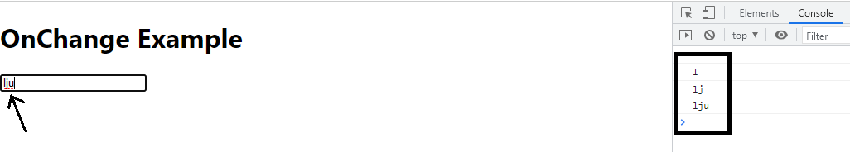

event.target gives the element that triggered the event.

So, event.target.value retrieves the value of that element (an input field, in above example).

1. **Example of DoubleClick event**

**Write react js script to display alert box with text “welcome to lju” only on double click.**

**Event3.js**

import React from 'react';

function Event3() {

const mystyle = {

color : "white",

backgroundColor : "#000000",

padding: "10px 20px",

margin:"30px"

};

const doubleClickHandler = (event) => {

alert("Welcome to LJU");

}

return (

<>

<button style={mystyle} onDoubleClick = {doubleClickHandler}>Double Click here</button>

</>

);

}

export default Event3;

**App.js**

import Event3 from "./Event3"

function App() {

return (

<div>

<Event3/>

</div>

);

}

export default App;

**Output:**

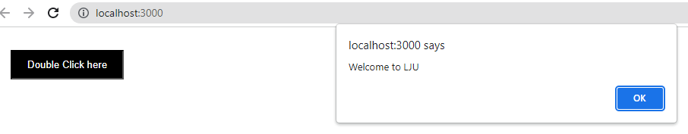

1. **Example of onSubmit event**

**Write react js script to display alert box with text “**You clicked submit.**” only on submitting form.**

**Event4.js**

function **Event4**() {

function **handleSubmit** (e) {

e.**preventDefault** ();

alert (' You clicked submit.');

}

return (

<form **onSubmit** = {**handleSubmit**}>

<button type="submit">Submit</button>

</form>

);

}export default **Event4**;

**App.js**

import Event3 from "./Event4"

function App() {

return (

<div>

<Event4/>

</div>

);

}

export default App;

**Example to understand concept of function calling without ()**

function App() {

const handleclick = () => {

alert('Welcome to LJU');

};

return (

<div>

<center>

<button onClick={**handleclick()**}>Click me</button>

</center>

</div>

);

}

**Output:**

On page load, the alert pops up: "Welcome to LJU"

But when you click the button, nothing happens because the onClick handler is now undefined.

**Explaination:**

The function handleclick() is being called immediately inside onClick={handleclick()} instead of passing a reference.

So, as soon as the component renders, it will call the function handleclick(). An alert box appears with the message “Welcome to LJU”

**React Routing**

Create React App doesn't include page routing. React Router is the most popular solution for page routing.

**Add React Router**

To add React Router in your application, run below command in the terminal from the root directory of the application:

**npm i react-router-dom**

**Folder Structure**

To create an application with multiple page routes, let's first start with the file structure.

Within the **src** folder, we'll create a folder named **routing** with several files:

**src\routing\:**

* Home.js
* Shop.js
* Contact.js
* Nopage.js

Each file will contain a very basic React component.

* **BrowserRouter:** It is used to keep your UI in sync with the URL. It is the parent component that is used to store all of the other components.
* **Routes:** An application can have multiple <Routes>. Routes are chosen based on the best match instead of being traversed in order.
* **Route:** It is used to define and render component based on the specified path. It will accept components and render to define what should be rendered.
* **Link:** Link component is used to create links to different routes and implement navigation around the application. It works like HTML anchor tag.

**Note:**Do not use anchor tags instead of <Link> components because using anchor tags would not allow applications to remain Single Page Application (SPA). HTML anchor tag would trigger a page reload or page refresh when clicked.

**Example:**

* Create react app to perform tasks as asked.

First create files as asked below in routing folder

1. Home.js - for the home page content
2. Shop.js - for the shop page content
3. Contact.js - for the contact page content
4. Nopage.js - for the page other than mentioned links

* Create Main.js file which contains Links for Home, Shop and Product page. Also, add functionality of page routing.Finally call Main.js in App.js.

App.js

Main.js

(Include all component and routing)

Home.js

(Home page content)

Shop.js

(Shop page content)

Contact.js

(Contact page content)

Nopage.js

(Page not found content)

App.css

**App.js**

import './App.css';

import Main from "./**routing**/Main.js";

function App() {

return (

<div>

<Main/>

</div>

);

}

export default App;

(Below all files are inside routing folder in src folder.)

**routing/Main.js**

import React from 'react';

import {BrowserRouter as **Router**,**Route**,**Routes**,**Link**} from "react-router-dom";

import Home from './Home';

import Contact from './Contact'

import Shop from './Shop'

import Nopage from './Nopage';

function Main() {

return (

<div>

**<Router>**

<div className='main-route'>

<ul>

<li><**Link** **to**="/">Home</Link></li>

<li><**Link** **to**="/shop">Shop</Link></li>

<li><**Link** **to**="/contact">Contact</Link></li>

</ul>

</div>

**<Routes>**

**<Route** **path**="/" **element**={**<Home/>**}/>

**<Route** **path**="/contact" **element**={**<Contact/>**}/>

**<Route** **path**="/shop" **element**={**<Shop/>**}/>

**<Route** **path**="*" **element**={**<Nopage/>**}/>

**</Routes>**

**</Router>**

</div>

);

}

export default Main

Setting the path to * will act as a catch all undefined URLs and display 404 error page.

**routing/Home.js**

import React from 'react'

function Home(){

return (

<div>

<h1>Home page</h1>

</div>

)

}

export default Home

**routing/Shop.js**

import React from 'react'

function Shop(){

return (

<div>

<h1>Shop page</h1>

</div>

)

}

export default Shop

**routing/Contact.js**

import React from 'react'

function Contact() {

return (

<div>

<h1>Contact Detail</h1>

</div>

)

}

export default Contact

**routing/Nopage.js**

import React from 'react'

function Nopage() {

return (

<div>

<h1>404 Page not Found</h1>

</div>

)

}

export default Nopage

**App.css (It is Not compulsory to add this file in this example. Added css for the reference only)**

.main-route ul {

list-style-type: none;

margin: 0;

padding: 0;

overflow: hidden;

background-color: #000;

margin-bottom: 50px;

}

.main-route li {

float: left;

}

.main-route li a {

display: block;

color: white;

text-align: center;

padding: 20px;

text-decoration: none;

}

.main-route h1{ color: red; text-align: center;

**Miscellaneous Examples**

**Create react component to perform the tasks as asked below.**

**Add array of 5 objects with properties Name and Age. Check if age is greater than 50 then display the person name of who are greater than 50 age.**

**M1.js**

**Using only map function to fulfil condition and to display values.**

import React from 'react'

function M1() {

const people = [

{

name: 'ABC',

age: 31,

},

{

name: 'XYZ',

age: 55,

},

{

name: 'PQR',

age: 36,

},

{

name: 'EFG',

age: 69,

},

{

name: 'DEF',

age: 34,

}

];

return (

<ul>

{

people.filter((p) => (p.age > 50)).map((p)=>{return( <h3>{p.name}</h3> )})

}

</ul>

) }

export default M1

**Example:2: Create react app to display students of CSE branch.**

**M2.js**

import React from 'react'

function M2() {

let students = [

{ id: "001", name: "N1", Branch: "CSE" },

{ id: "002", name: "N2", Branch: "CE" },

{ id: "003", name: "N3", Branch: "CSE" },

{ id: "004", name: "N4", Branch: "CSE" },

{ id: "005", name: "N5", Branch: "IT" }

]

return (

<div>

students.filter((student) => (student.Branch === "CSE")).map((student)=>{return( <h3>{student.name}</h3> )})

</div>

)

}

export default M2

**Example3: Create react app to pass product image, name and price as properties from one component to another component. Add an array of objects with pic, name and price properties of 2 products. Display Image name and price of the products in browser using map method.**

**P.js (Pass the data)**

import P1 from "./P1";

import img1 from "./img1.png"

import img2 from "./img2.png"

function P(){

const prod=[

{

pic:img1,

name:"Product1",

price:3000

},

{

pic:img2,

name:"Product2",

price:3000

}

]

return(

<div>

<P1 info={prod}/>

</div>

)

}

export default P

**P1.js (Read the data)**

import React from "react";

function P1(prop){

return(

<>

{

prop.info.map((pr)=>{

return (

<div>

<img src={pr.pic} alt="No Image" />

<h2>{pr.name}</h2>

<h3>{pr.price}</h3>

</div>

)

})

}

</>

)

}

export default P1

**Import P component in App.js file**

**Example 4**

**Create a React app to perform the following tasks using functional components:**

**Implement the following components in your React application:**

* Main.js to set up the router and define the routes.
* Home.js for the Home page.
* Product.js for the Product page.

1. **Create a React Router:**
   * Include two routes: Home and Product. Implement navigation between these routes.
2. **Create the following routes and components:**
   * When a user clicks on the Home page link, it should navigate to the Home page and display "Welcome to LJU" within an <h1> heading with blue color. Also, include link to product page.
   * A **Product** page that displays three products' information (name, price, and image) using props. When a user clicks on the Product page link, it should navigate to the Product page and display three products' information name, price and product image using props.

**Main.js**

import {BrowserRouter as Router,Route,Routes,Link} from "react-router-dom";

import Home from './home';

import Product from './product'

import Nopage from './nopage';

import img1 from "./img1.jpg"

import img2 from "./img2.jpg"

import img3 from "./img3.png"

function Main() {

    const products=[{name:"p1",price:20000, pic:img1},{name:"p2",price:14000, pic:img2},{name:"p3",price:40000, pic:img3}]

return (

<div>

    <Router baseName="/calendar">

       <div className='main-route'>

              <ul>

                <li><Link to="/">Home</Link></li>

                <li><Link to="/product">Product</Link></li>

              </ul>

        </div>

        <Routes>

            <Route path="/" element={<Home/>}/>

            <Route path="/product" element={<Product info={products}/>}/>

            <Route path="*" element={<Nopage/>}/>

        </Routes>

    </Router>

</div>

);

}

export default Main

**home.js**

function Home(){

return (

<div>

<h1 style={{color:"blue"}}>Home page</h1>

<a href="/product">Product</a>

</div>

)

}

export default Home

**nopage.js**

function Nopage() {

return (

<div>

<h1>404 Page not Found</h1>

</div>

)

}

export default Nopage

**product.js**

const Product = (Props)=>{

return(

<div>

    {

        Props.info.map((p)=>{

            return(

                <div>

                    <img src={p.pic} alt="product" height={200} width={200}/>

                <h1>{p.name}</h1>

                <h1>{p.price}</h1>

                </div>

            )

        })

    }

<h1>{Props.Name} : {Props.Price}</h1>

</div>

);

}

export default Product;

**Example 5**

**Create a component to perform the tasks as described below:**

**1. Add a text field and a submit button.**

**- While changing the value in the text field, display it below the form.**

**- Display this text field value in an alert box upon submitting it.**

**2. Add a button to perform click and double-click event tasks.**

**- On click event, display message in h3 tag “You clicked once”.**

**- On double-click event, display message in h3 tag “You clicked twice”.**

**- Message should be displayed below the button.**

function Map1() {

const arr=[1,2,3,4,5];

function handleSubmit (e) {

e.preventDefault ();

alert (document.getElementById('uname').value);

}

function handleclick(){

document.getElementById('test1').innerHTML = “You clicked once”

}

function handledoubleclick(){

document.getElementById('test1').innerHTML = “You clicked twice”

}

function handleChange(event) {

document.getElementById('test').innerHTML =event.target.value;

}

return (

<div>

<form onSubmit = {handleSubmit}>

<input type="text" id="uname" onChange={handleChange}></input>

<input type="submit"/>

</form>

<h1 id="test">On change event</h1>

<button style={{backgroundColor:'black',padding:"20px",color:"white"}} onClick={handleclick} onDoubleClick={handledoubleclick}>Click</button>

<h1 id="test1">Click/DoubleClick event</h1>

</div>

)

}

export default Map1